IOS (Applies to Android for similar situation)

**Please make sure the mods are done accordingly, if there’s extra cost not covered in the first quote please let me know, we will pay for it.**

# Change for Category Page, please add popup modal window for item has custom options (with image).

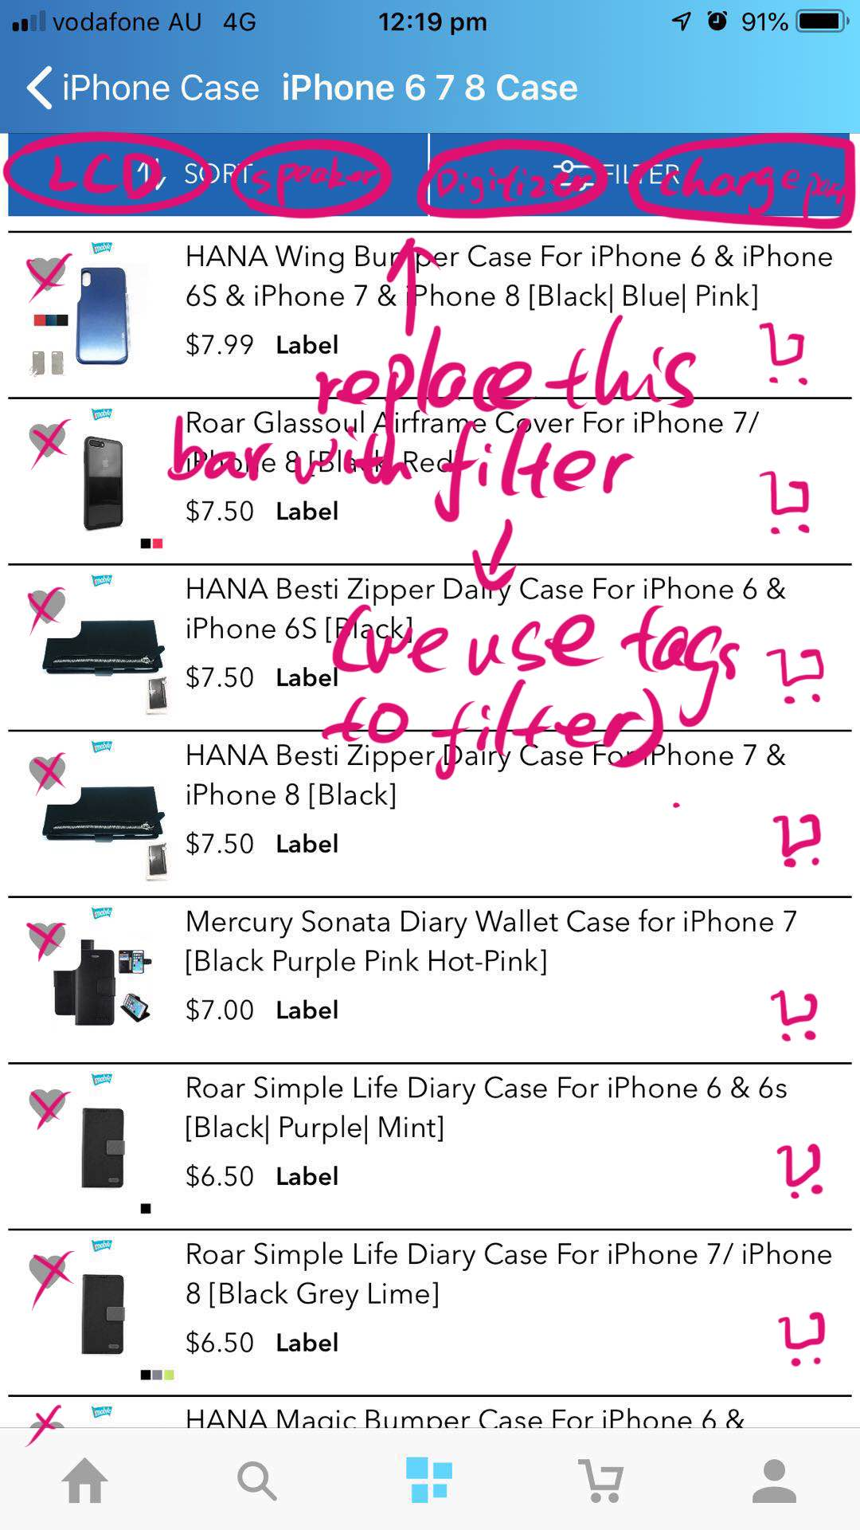

Figure Category page add to cart button

Please add and delete these buttons accordingly.

Ideally we do not need a product page, and instead will have a small popup modal (please do minimalism design) when product list is clicked. So the modal replaced the product page.

And also, when cart button is clicked, one of these two things will happen.

1. If product have no option, add 1 item to cart directly for each click.
2. If product have options (phone cases will have colour options), go to the popup modal for product.

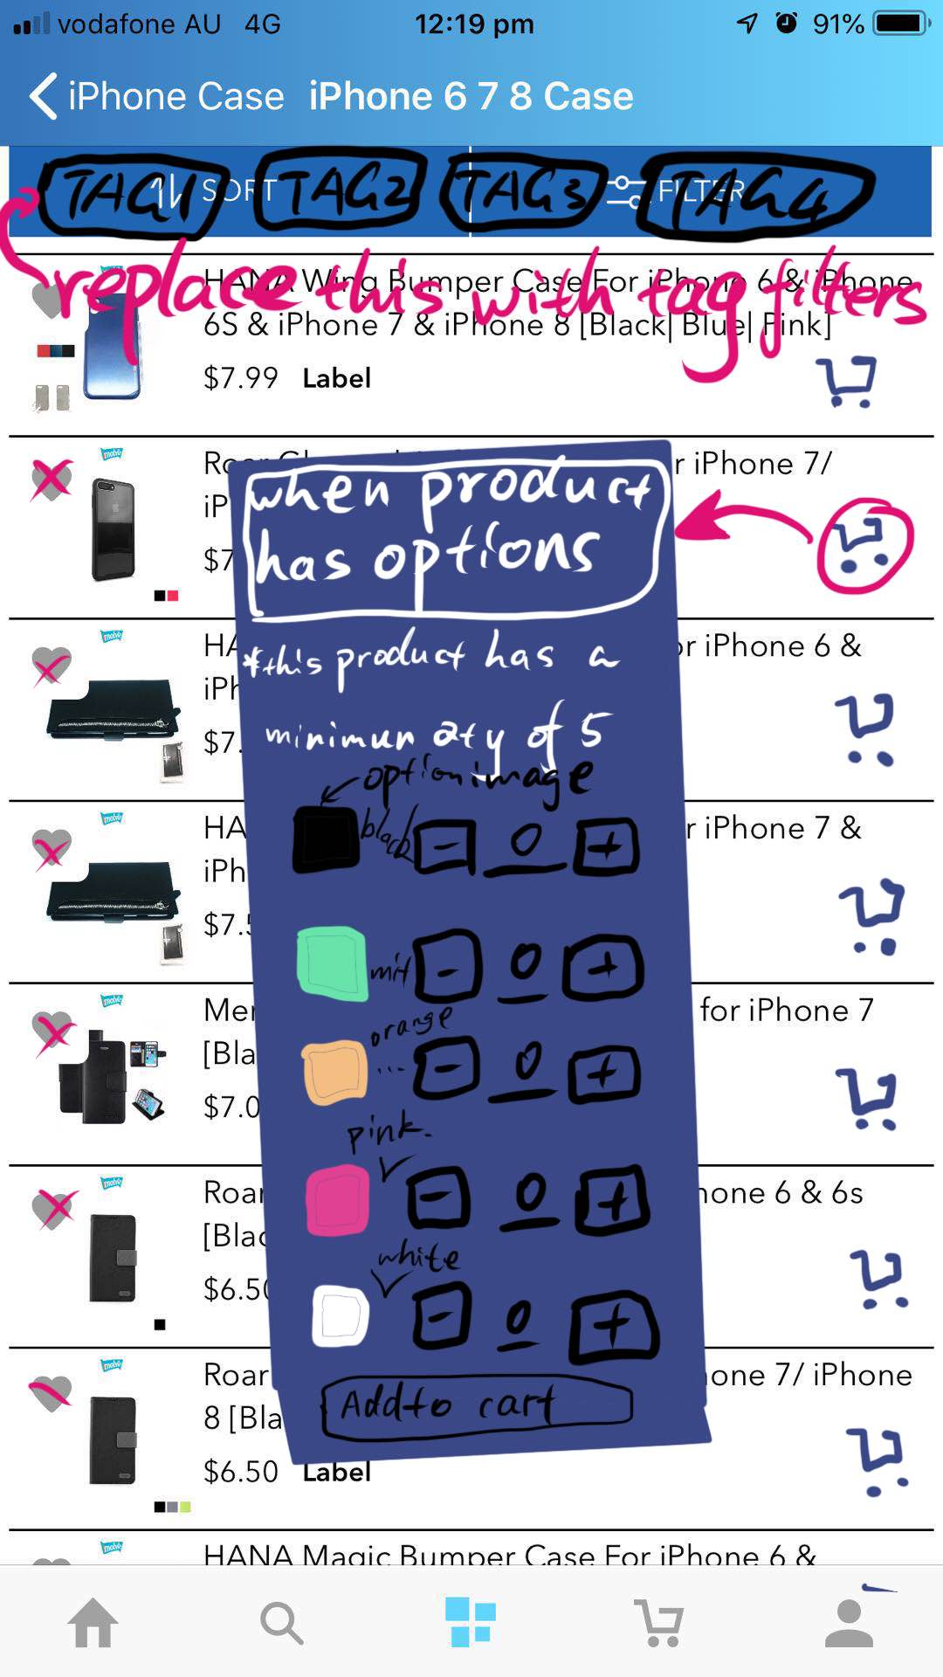

Figure popup modal for custom options with image

<https://duinobot.com.au/one/cases-and-accs/iphone-case/iphone-6-plus-7-plus-8-plus-case>

All our cases have colour option with image and a minimum order number of 5.

Please use this login detail to see

User: [dan@imobilestore.com.au](mailto:dan@imobilestore.com.au)

Pw: 123456

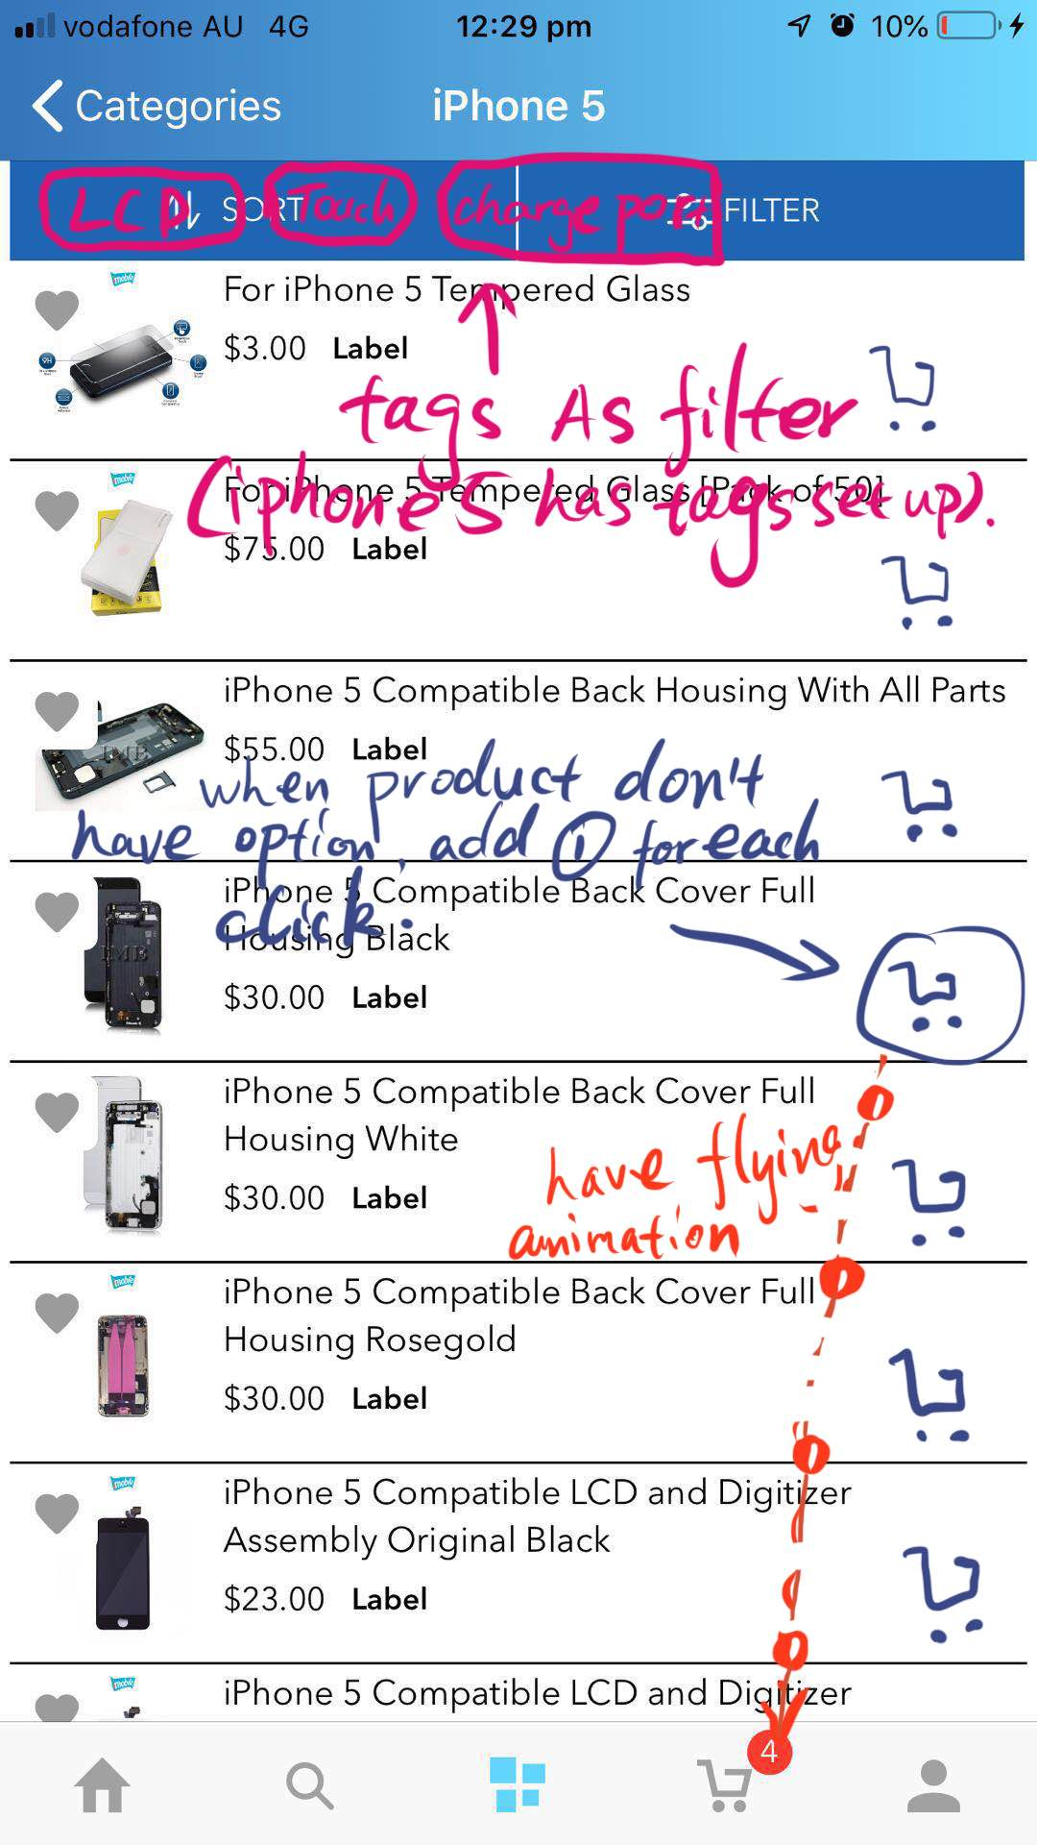

Figure When items don't have options add 1 to cart directly

Please show animation (something fly to the cart and update the cart item count) when clicked on the cart button as shown above,

# Bug when adding items with options.

Currently we cannot order cases because there’s no product option. Adding them to cart the app will crush.

# Replace or delete “add to wish list”, and add “add to cart”

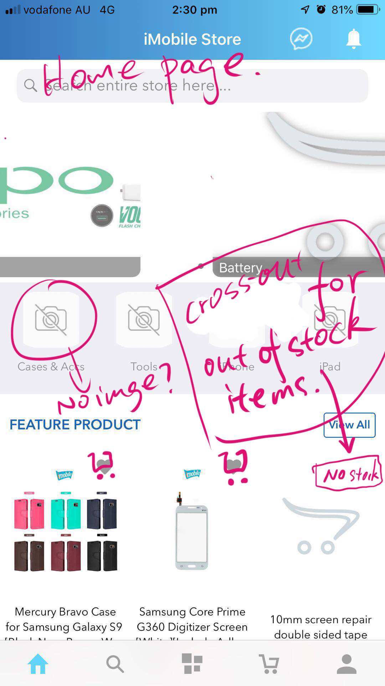

Figure Change “add to wish list” buttons to “add to cart” buttons.

Change “add to wish list” buttons to “add to cart” buttons.

Add 1 item to cart for each click when item has no option and is in stock.

Use Popup modal as show in section 1 on category and home when item as options.

# Product page

When a product is clicked, go to product page.

When a product is with options, use following design. (We have a minimum order quantity of 5.)

# C:\Users\User1\AppData\Local\Temp\WeChat Files\358770437608400520.jpg

Figure Product page for product with option

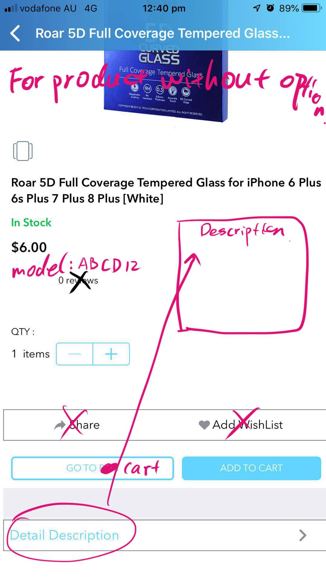

Figure Product page with no option

# Move the messenger button to somewhere conspicuous

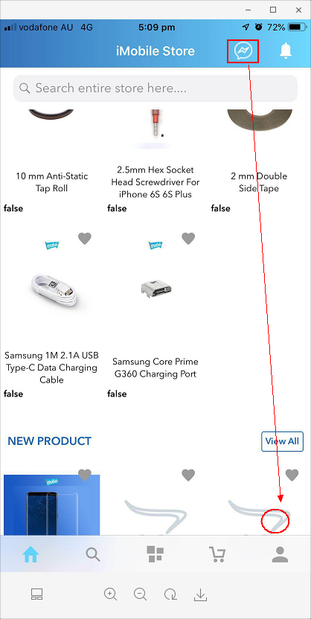

Figure Facebook messenger button

Move messenger icon to here like android, please use high definition image instead of the blur ones please. ;)

# No filter info available

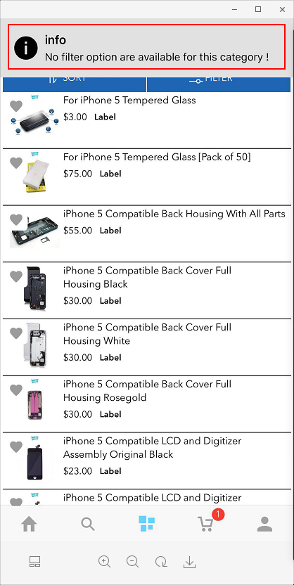

We are using product tag as filter. We will limit the filter to 7-10 tags.

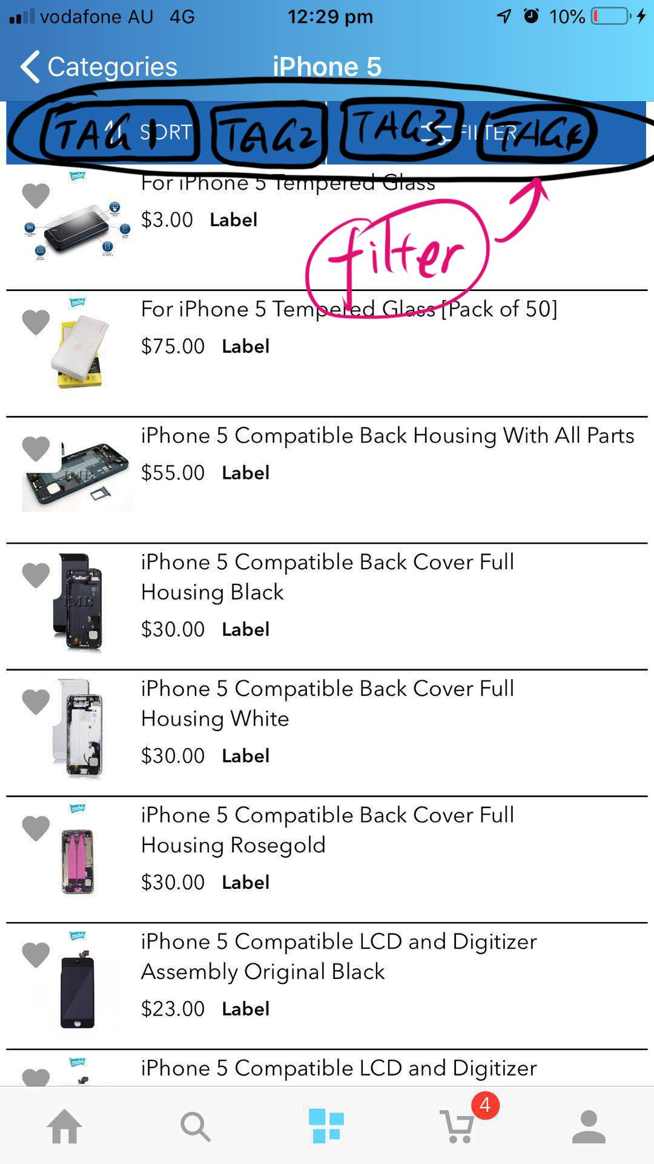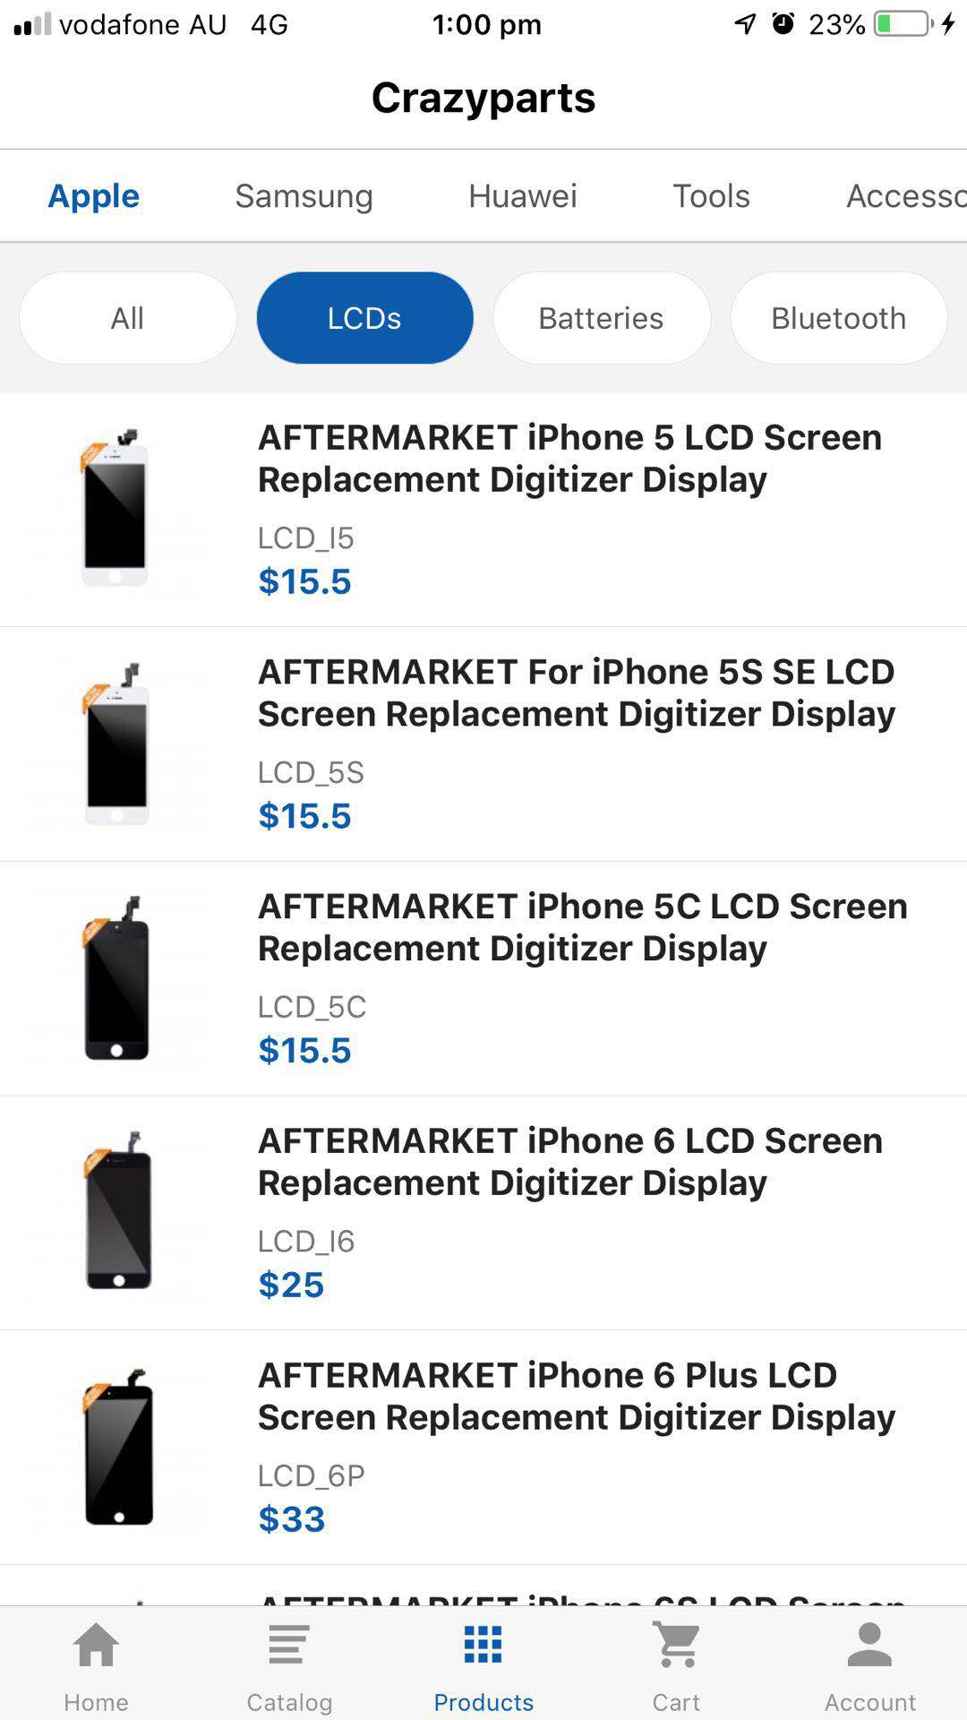

# 

Figure 9 Remove the sort and filter bar, add filter tags instead.

# Out of stock

When item is out of stock, don’t allow customer to add item to cart.

Remove add to cart button and display out of stock sign clearly.

Here are some example designs but it doesn’t need to be followed if you have better design.

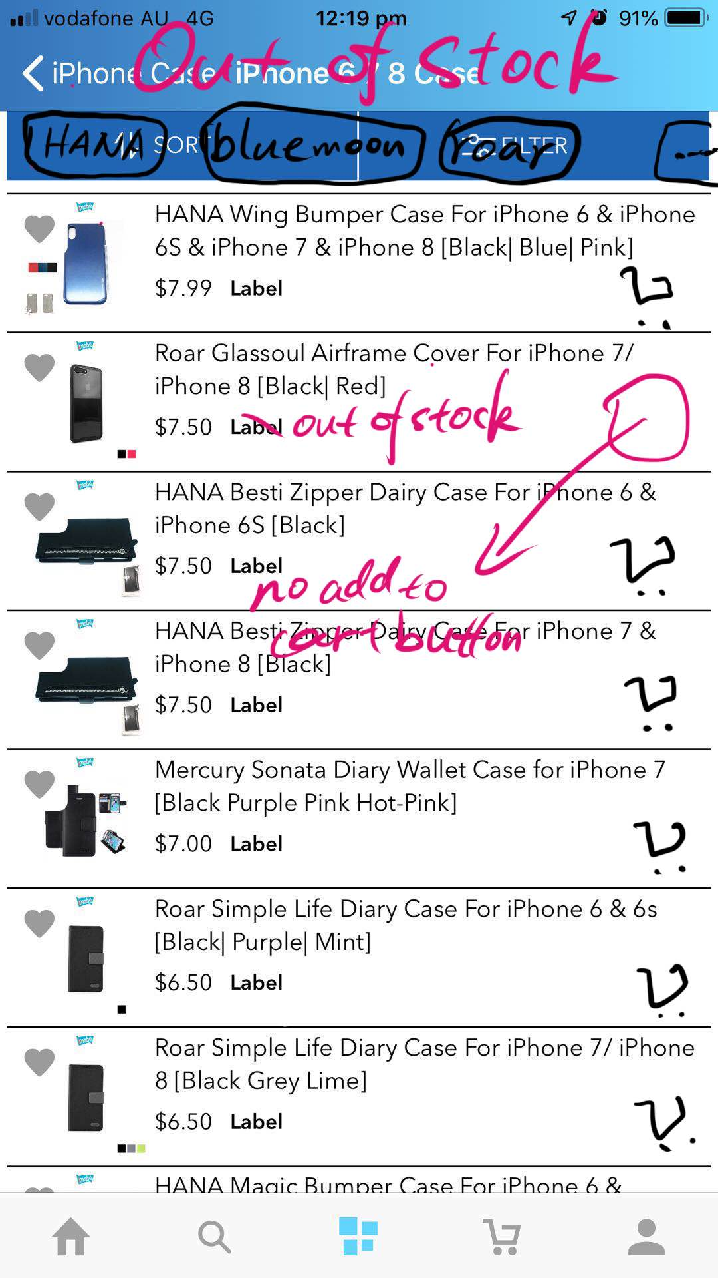

Figure Out of stock status and no add to cart button

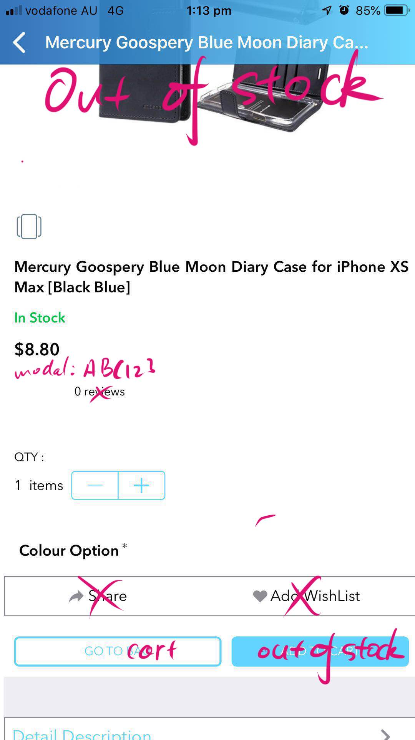

Figure Product page when out of stock



Figure Homepage when out of stock

# Abandon cart firebase notification.

We have an abandon cart function to remind customer to order before 4pm cutoff time everyday.

The plugin is in extensions->modules->abandon cart

Are we able to push a notification to phone as well?

